E.R.F.F.A.
Evanston Retired Fire Fighters Association

Bob Nelson Ronn Gannon
Firefighter Retired Division Chief Retired
President Secretary

Mailing address:
E.R.F.F.A.
C/O Bob Nelson
354 S. Dryden Pl.
Arlington Heights, IL 60005
E-mail: ninabob354@yahoo.com
Phone# 847-814-2102

To All E.R.F.F.A. Members:
Summer is over, now it’s time to think about going on a winter vacation or going south for the winter. Not too much news to report. On September 8, 2012, Local 742 had the Annual Dinner Dance. Battalion Chief Don “Rudy” Kunita was honored for his 36 years of service. E.R.F.F.A. members from as far away as Tennessee and Minnesota attended the Dinner. Welcome to E.R.F.F.A. Don and may you enjoy your retirement for a long time.
Some of are members are having some medical issues at this time. Please keep them in your thoughts and prayers.

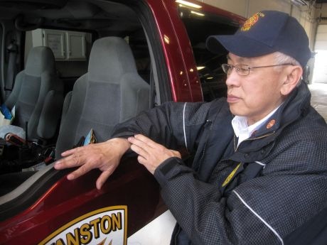
B/C Don “Rudy” Kunita

On September 25, 2012 Patti Reif passed away. I just heard that Retired (1981) Captain Bill Moore passed away. May they rest in peace.

Ron Brumbach announced his retirement effective 11/17/12 after 35 years

As we all know this is an election year and we must stay informed. The IAFF web site, www.IAFF.org is a good place to look for Legislation and Legislative Information. Another site is The Illinois Professional Firefighters Association web site, www.ipfaonline.org. Stay Informed!

Legislation and Legislative Issues
The IAFF actively works to influence federal legislation that directly affects the jobs, economic security and safety of IAFF members. Below are links to fact sheets and other information regarding IAFF priority legislation in the 112th Congress. Additionally, the status charts on the below provide information on some of the issues the IAFF has worked on over the past several years.
IAFF Priority Legislation in the 112th Congress
- Economic Issues
  - Public Sector Pensions , Chart 111th Congress ,
  - Health Care Tax Exemption
E.R.F.F.A. Fall Luncheon
Will be at Noon on November 7, 2012 at The Des Plaines Elks Lodge #1526, 495 Lee Street, Des Plaines, IL. 60016.
A few months ago about ten of us went the Elks Club for dinner. We found the food to be very good and the Club to be very nice. The cost will be $10:00 per person. They have a full service bar for those who wish to have a cocktail.

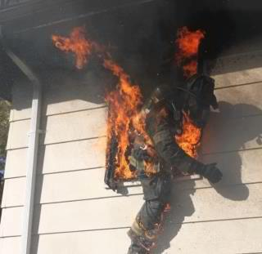
So, you think you have a bad day at work when
your computer is slow. This is a bad day at work.

EVANSTON RETIRED FIRE FIGHTERS ASSOCIATION
BANK STATEMENT  AUGUST 31, 2012 | Secure Message CenterOpens overlay  |  Customize AccountsOpens overlay
ninabob354@yahoo.com | Last logged on at 2:46 PM ET on 09/24/2012 | See session summary

Top of Form


Account Summary
EVANSTON RETIRED FIRE FIGHTERS A
Deposit accounts | $1,144.73
Business Accounts

Business Accounts

 | Deposit Accounts | Total balance: $1,144.73
 | Account
 | BUSINESSSELECT CHKG (...6009)
  Present balance | $1,144.73
  Available balance | $1,144.73

Reminder: Dues for E.R.F.F.A.
Retired members 65 years and younger = $14.00 per year
Over 65 = $8.00 per year
Over 70 = $2.00 per year
I want to thank all who have paid their dues and support ERFFA.

Hope to see you on November 7, 2012 at the Luncheon.
Bob Nelson

Bottom of Form

