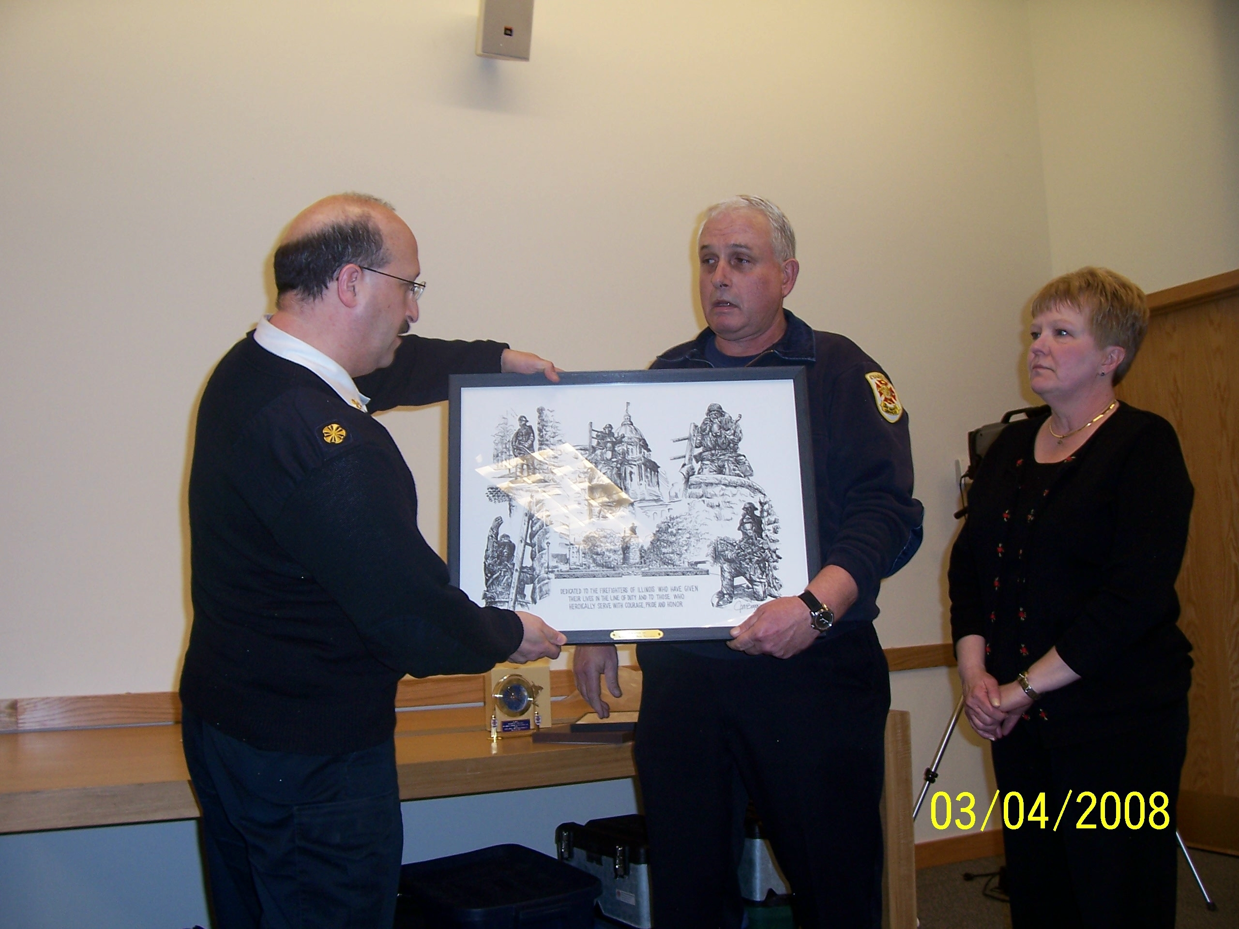
Bob Nelson and wife Nina present art work to Chief Berkowsky and the Evanston Fire Department on March 4, 2008 at Fire Department Headquarters.

On March 4, 2008 Bob Nelson retired from the Evanston Fire Department with 24 years of service. Bob started with the City of Evanston in 1980 working at Fleet Services as a mechanic. At his retirement celebration Bob and his wife Nina presented a limited edition artwork to Chief Berkowsky and the Evanston Fire Department.
In 1993 the Illinois Fire Services Association unanimously agreed that a monument should be erected to serve as the official memorial; it was to be located on the grounds adjacent to the state Capitol building. The Memorial will be viewed by thousands of visitor’s year ‘round. The Firefighting Medal of Honor Committee, appointed by the Governor, assumed the responsibility of bringing the Memorial to reality.
Working with the Secretary of State’s office, the Office of the State Fire Marshal, and a nationally recognized sculptor, the committee developed a design concept to transform the site into a Memorial in which the fire service of Illinois will be proud. The Illinois Firefighter Memorial is dedicated to the firefighters of Illinois, who have given their lives in the line of duty and to those firefighters who heroically serve with courage, pride and honor.
The artist was commissioned to design and construct an original bronze work of art consisting of four life-size figures of firefighters in full gear, a child, a ladder and hose. Each adult figure is approximately 6’ 2” tall if in a standing position and represents the firefighters in full protective clothing, in action.
The artwork is on display at Fire Department Headquarters. When you view this artwork take a moment to remember all fallen firefighters and retired firefighters.
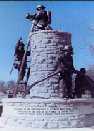
  DEDICATED TO THE FIREFIGHTERS OF ILLINOIS WHO HAVE GIVEN THEIR LIVES IN THE LINE OF DUTY AND TO THOSE WHO HEROICALLY SERVE WITH COURAGE, PRIDE AND HONOR.

