Fire Line

Firefighters

Directory

twelve EDITION

July, 2011

Fire Line

Compiled By

Thomas Linkowski
Division Fire Chief Retired
tlink36@embarqmail.com

Greg Klaiber
Fire Chief
GKlaiber@cityof Evanston.org

Last Alarm

( Since our previous edition – September 2009 )

Patrick Reif 01/18/10
Richard Ruley 04/01/10
David Franzen 07/29/10
Edward Pettinger 11/12/10
Daniel Lorden 06/24/11
Gordon Olsen 08/07/11

Dedication

This booklet is dedicated to all the Retired Evanston Firefighters that have served in the fire service before us. We all are just one in the long line of successors that had the responsibility of protecting life and property.

Evanston, Illinois Firefighters Pension Fund

702 Madison Street Evanston, Illinois 60202-2205

Board of Trustees

(847)
(847) 869-2291 (FAX)

Meeting Date: Quarterly

President
Deron Daugherty Firefighter/ Paramedic (847) 866-5920
ddaugherth@cityofevanston.org Shift #1 (Gold)

Secretary
Sean Heneghan Firefighter/Paramedic (847) 866-5920
sheneghan@cityofevanston.org Shift # 2 (Black)

TREASURER

Trustees
Patrick Dillon Captain (Retired) (773) 784-4038
Joseph Romano Citizen Mayor appointed
Elizabeth Rorke Citizen/Mayor Appointed (847)

www.cityofevanston.org/government/bcc/firepension.shtml

The Evanston Firefighter Pension Fund has an investment committee:

The Evanston Firefighters’ Pension Fund is operated in compliance with Illinois State Law. The Illinois Compiled Statutes, Pension, Illinois Pension Code, 40 ILCS 5/4 (101-144). Pension Article 4 covering municipalities with population less than 500,000 inhabitants.

Revised: House Bill 1403 (P.A. 94-317) 07/25/05

www.legis.state.il.us/illinoiscompiledstatues

New Pension Board as of April 17, 2006

The Board of Trustees is comprised of five (5) members (4-121)
2 members elected by Active Firefighters
2 members appointed by the Mayor
1 member elected by the Retired Firefighters
08/01/11

Retired Evanston Firefighters

Pension Recipients .. …………………………………………………………………….. 139
Retired Firefighters…………………………………………………………………….…… 106
Surviving Spouses …………………………………………………………………………… 33
Dependent Children……………………………………………………………………………..0
Dependent Parents………………………………………………………………………………0

Average Retired Firefighter Age.……………………………….66.5

Average Years of Service ………………………………………26.4

Total Years of Service…. ……………………………………2794.6

Senior Retired Firefighter
Willard Thiel 95 years & 8 months young

Retired Firefighter with the most years of fire service
Sanders Hicks 37 years & 7 months

Retired Firefighter First Hired
Willard Thiel (01/01/41) 70.5 years

Firefighter Retired the Longest

Kenneth Holmes (04/25/62) Disability 49 years & 2 months
Thomas Hanson (09/09/68) Service 42 years & 10 months

106 Pensions:

82 Service (20 or more years of service)
12 Disability (20 or more years of service)
12 Disability (Less than 20 years of service)

106 Firefighter’s Rank at Retirement

2 Fire Chiefs 1.9 %
4 Deputy Chiefs 3.8 %
7 Division Chiefs 6.7 %
3 Assistant Chiefs 2.9 %
3 Shift Chiefs 2.0 %
39 Fire Captains 36.1 %
48 Firefighters 45.7 %

106 RETIRED FIREFIGHTERS LIVIVG IN:

86 ILLINOIS 81.1 % 12 EVANSTON 11.4 %

1 Arizona 0.95 % 1 Michigan 0.95 %
2 California 1.90 % 1 Minnesota 0.95 %
1 Colorado 0.95 % 1 New Mexico 0.95 %
6 Florida 05.7 % 1 Tennessee 0.95 %
1 Indiana 0.95 % 3 Wisconsin 2.86 %
2 Massachusetts 1.90 %
08/17/11

E. R. F. F. A.

Evanston Retired Firefighters Association

BOB SCHWARZ Captain Retired President

Mailing Address: Evanston Retired Firefighters’ Association
Bob Schwarz
337 Elm Street
Glenview, IL. 60025
(847) 729-3401
Schwarz123@AOL.Com

Birthday Listing

Bogard, Michael | 01/05/63
Hanson, Thomas | 01/08/27
Burczak, Bernard E  Kavanagh, Thomas | 01/13/24  01/16/47
Smithwick, Neal | 01/18/38
Frake, Edward M  Miller, Art  Martin, Dean | 01/20/28  01/20/53  01/21/59
Fisher, John  Mortrell, Jack  Hayden, Robert  Dunbar, Milton  Dohm, Kenneth | 01/26/40  01/26/54  01/27/49  01/29/48  01/30/52
Erpelding, Peter | 02/01/26
Holmes, Kenneth | 02/07/24
McIntyre, James | 02/08/35
Becker, Robert | 02/09/39
Gschwind, Donald | 02/14/44
LoBianco, Louis M  Williams, Clyde | 02/14/51  02/15/51
Hrejsa, John | 02/16/40
McDermott, Jerome | 02/16/40
Neuhaus, George  Hilbert, Gary  Whalen, Michael | 02/18/27  02/23/49  02/24/51
Semrow, Kenneth F  Nelson, Robert A. | 02/26/49  02/28/49
Hatfield, Kenneth | 03/01/37
Hicks, Sander | 03/03/27
Sheaffer, Max L | 03/03/34
Simpson, Thoma  Dillon, Patrick  Lecey, Roger, Roger V. | 03/03/52  03/05/53  03/16/29
Cox, James M.  Haltom, Blair  Cook, Ward  Gannon, Ronn F. | 03/19/51  03/23/54  03/28/44  03/31/52
Vacala, Lawrence  Rodriquez, Jude  McLaughlin, James | 04/01/55  04/05/75  04/06/43
Williams, Donald  Freeman Bruce L  DuPont, James | 04/10/46  04/12/52  04/13/57
Kelly, Kevin C.  Erpelding, Thomas  Coleman, Wayne  Wright, John L. | 04/15/52  04/23/53  04/27/53  05/04/40
Heber, Jerrold | 05/06/49
Linkowski, Thomas | 05/07/37
Bush, Roger  Nolan, Mario P. | 05/07/48  05/15/55
Moore, William L | 05/16/28
Foley, Peter D | 05/20/54
McGowan, Fred  Schumacher, Rick | 06/13/27  06/17/52
Kloiber, John W | 06/28/40
Pettinger, Roger J | 07/04/29
Pettinger, David | 07/08/47
Conrad, Leonard  Hunter, Samuel S. | 07/12/30  07/19/51
Kostopoulas, Thomas  McGuigan, Thomas | 07/24/22  07/25/55
Mersch, James F  Dillon, James  Perkiser, Jason P. | 07/29/37  07/30/48  07/30/74
Olson, Darold  Cox James A. | 08/06/35  08/06/56
Lemieux, William F  Strom, George | 08/08/31  08/09/26
Reid, William | 08/10/53
Lynn, Patrick | 08/10/43
Whalen, James  Schwarz, Robert B | 08/13/25  808/27/35
Keaty, James  Brandt, Karl W. | 08/27/50  09/06/58
O’'Malley, David | 09/07/46
Suther, David  Smith, Jobe E.  Dickman, Kurt P. | 09/10/54  09/26/56  09/27/55
Czarnowski, Jerome | 09/28/45
Leoni, Greg J.  Rukse, Richard H  Brewer, John | 09/30/59  10/04/30  10/08/47
Hayes, James C | 10/13/49
Marti, James L | 10/19/41
Burns, Philip  McCafferty, Brain | 10/23/48  10/23/51
Sherrie, Donald E  McGuigan, Dennis A. | 10/24/27  10/27/56
Boddie, Samuel | 10/28/48
Drott, Randall A  Jaremus, Ben | 10/30/44  11/03/53
Borre, Richard  Edwards, James C. | 11/11/54  11/11/59
Swanson, Gary J | 11/12/53
Thiel, Willard M | 11/13/15
Marti, Robert  Meier, Michael E. | 11/15/46  11/16/53
Becker, John H.  Cleland, David A  Wagner, Robert G.  Ghiselli, Benito | 11/22/26  11/26/47  12/03/09  12/07/23
Lord, Charles E | 12/11/47
Brown, Robert  Henderson, Dave R  Berkowsky, Alan | 12/25/46  12/29/25  12/29/58

Evanston Fire and Emergency Service

www.cityofevanston.org/departments/fire/admin.html

Administration

FIRE CHIEF

greg klaiber

Division Chiefs

Geoffrey Block Training/Administration Service
Thomas Janetske Fire Prevention/EP
Dwight Hohl Life Safety Service

Shift Chiefs

Donald Kunita Shift 1 ( Gold )
David Arreguin Shift 2 ( Black )
Jeffrey McDermott Shift 3 ( Red )

Organizational Chart

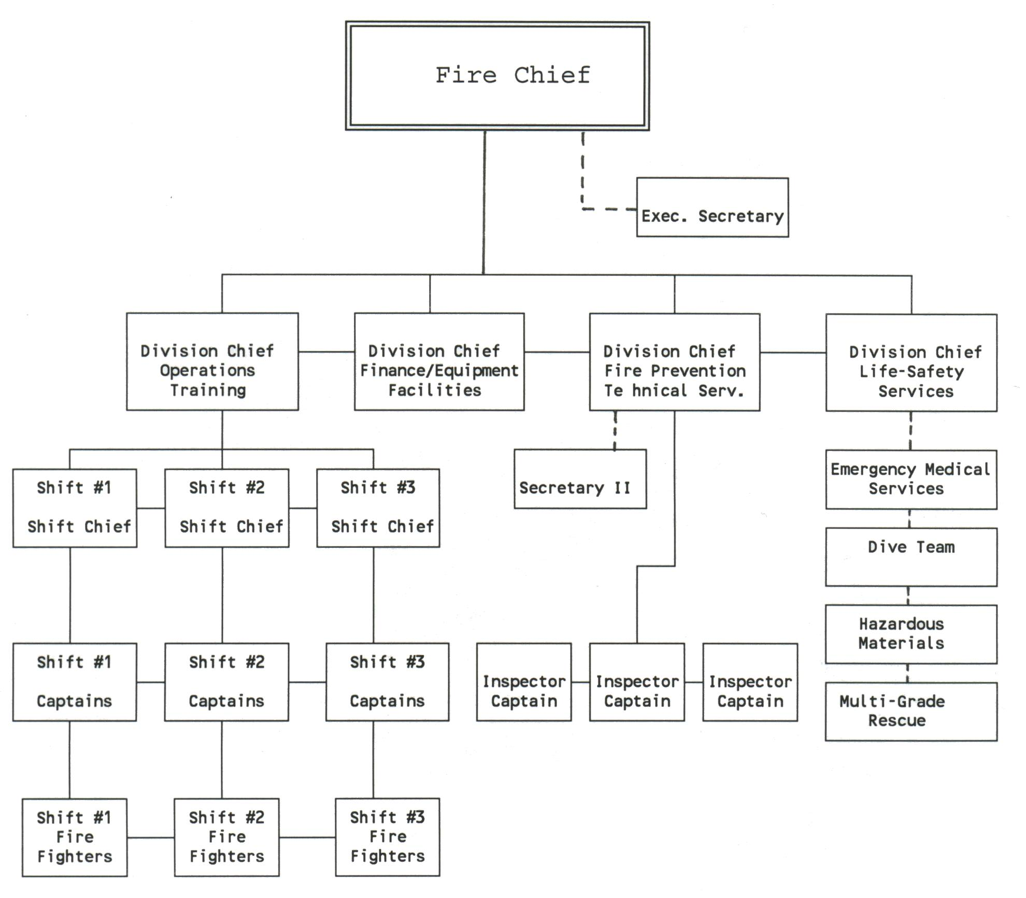

Evanston Fire & Life-Safety Services

www.cityofevanston.org/departments/fire/fire_suppression.html

Fire Chief

Greg Klaiber

STAFF

Block, G. Hohl, D. Janetske, T.
Fochs, D. Novak, P.
Whalen, M. M. Rons L. Grimm

Shift 1 Gold | Shift 2 Black | Shift 3 Red
Shift Chief  Kunita, D. | Shift Chief  Arreguin, D. | Shift Chief  McDermott, J. B.
Captains  Anderson, M.  Brumbach, R  Casey, P.J..  Grizely, M..  McDermott, M.  Muno, W  Rafaczz, M.  Shulga R. | Captains  Adam, M.  Bednarz, C.  Casey, P. A.  Goldman, M.  Kull, K.  McDonnell, M.  Perrino, E.  Polep, P | Captains  Betke Jr., W.  Boetto, J.  Boliaux, G.  Lermer, A.  Ready, S.  Scott, B.  Taylor, T.  Vanek, G.
Firefighters  Bailey, D.  Barlock, S.  Brannan, C,  Byrne, R..  Collins, B.  Connor, C  Daugherty, D.  Eaton, J.  Fochs, C.  Gobat, T.  Handelsman, L.  Henderson, N  Jean-Pierre, D..  Lindstrom, D.  Martin, C.  Migon, T.  Norris, J.  Perrino, M.  Quinones, J.  Roche, J.  Rodriquez,K.  Schuster, J.  Smrha, D.  Youpel,T.  Zaremba, K. | Firefighters  Davis, R.  Dwyer, K.  Edwards, C.  Ellis, D.  Gatewood, B.  Gonzales, J.  Grish, G.  Hargreaves, S.  Hasanov, M.  Heneghan, S.  Kamarchevakul, M.  Lipp, D.  Morson, J.  Moskal, J.  O’Gara, T.  Palomare, S.  Peters, J.  Roche, K.  Roeder, R.  Smith, M.  Wideman, M.  Wilson, K  Wojtowycz, S..  Yee, A. | Firefighters  Arrequin, A.  Bazan, D.  Bevins, D..  Buchananan, M.  Ceriale, J.  Davis, W.  Fakhoury, J.  Haglund, J.  Hays, J.  Hicks, G.  Howard, T.  Jaimez, A.  Jennings, M.  King, P  Lakin, H..  LoBianco, J.  Lynch, D.  Malloy, S.  Mosberg, P.  Rodriguez, R.  Spillane, M.  Szostak, M.  Weglarz, C.

EVANSTON FIREFIGHTERS ASSOCIATION

P. O. Box 1275, Evanston, IL 60204

www.unionfireweb.com

International Association of Firefighters

Local No. 742 EXECUTIVE BOARD
President……………… Brian Scott
brianscott@comcast.net
Vice President ……….Marty Rafacz
Rafacz13@yahoo.com
Treasure………………….Kim Kull
Secretary ………. Dan Lynch
Lynch217@gmail.com
Steward ……… Matt Migon
Steward ……… ……… Matt Smith

Trustees Stewards
Michael Adam Chuck Bednarz Tim O’Gara Dan Bevins
Michael McDonnel Matt Grizely Howard Lakin Rob Byrne
Steve Perrino Mike McDermott Matt Smith Tim Migon

FyrEater21@aol.com Jeff Boetto Union Web Page Manager

www.efdlocal742.com 05/01/10 – 12/31/11 Labor Contract

07/01/11

Fire Stations Addresses ZIP Telephone

Headquarters 909 Lake Street 60201 (847) 866-5918
(847) 866-8729 (FAX)

Station 1 1332 Emerson St. 60201 (847) 866-5910

Station 2 702 Madison St. 60202 (847) 866-5920

Station 3 1105 Central St. 60201 (847) 866-5930

Station 4 1817 Washington St. 60202 (847) 866-5940

Station 5 2830 Central St. 60201 (847) 866-5845

RETIRED EVANSTON FIREFIGHTERS

BECKER, JOHN becker702@comcast.net
BERKOWSKY, ALAN Pitoys@aol.com
BODDIE, SAMUEL E. Sam127@att.blackberry
BOGARD, MICHAEL mikebogard@comcast.net
BORRE, RICK RickBorre@sbcglobal.net
BREWER, JOHN jwbbrewer@aol.com
BROWN, ROBERT W. rbrown66@att.net
BURNS, PHIL mischief600@comcast.net
BUSH, ROGER rogbon123@yahoo.com
CLELAND, DAVID A. DAC56@rcn.com
COLEMAN, WAYNE excellserv@yahoo.com
CONRAD, LEONARD P. icconrad2@walmartconnec.com
COOK, WARD M. wmcook44@yahoo.com
COX, JAMES M. betty.jim@dishmail.net
COX, JAMES jcox742@comcast.net
CZARNOWSKI, JEROME A. ski2@sbcglobal.net
DICKMAN, KURT firekpref@aol.com
DILLON, JAMES jd1211@aol.com
DILLON, PATRICK J. mrpjd1@sbeglobal.net
DOHM, KENNETH dohmkenneth@yahoo.com
DROTT, RANDALL RADrott@aol.com
DuPONT, JAMES jpdupont@comcast.net
EDWARD, JAMES goldwnjim@aol.com
FISHER, JOHN jfisher466@sbcglobal.net
FOLEY, PETER peterfoley@sbcglobal.net
HALTOM, BLAIR Bhaltom4@aol.com
HAYDEN, ROBERT L. captbob23@comcast.net
HEBER, JERROLD Heber225@aol.com
HICKS, SANDERS shicks5877@aol.com
` HILBERT, GARY deehealthnut@sbcglobal.net
HREJSA, JOHN G. dhrejsa@accgroup.c
HUNTER, SAMUEL FAAM1998@aol.com
JAREMUS, BEN bennieJ@aol.com
KAVANAGH, THOMAS kavanagh2940@comcast.net
KEATY, JAMES keatyville@hotmail.com
KELLY, KEVIN C. kkelly52@aol.com
KLOIBER, JOHN john.kloiber@sbcglobal.net
LEONI, GREG greg.loni@yahoo.com
LINKOWSKI, TOM tlink36@embarqmail.com
LOBIANCO, LOUIE tlobianc@corboydemetrio.com
LORD, CASEY clord42@comcast.net
LYNN, PATRICK pjlynn1943@yahoo.com
MARTI, JAMES L. Marti-james@yahoo.com
MARTIN, DEAN mack2121@comcast.net
McCAFFERTY, BRAIN bmccaf@comcast.net
McDERMOTT, JERRY jmac461@sbeglobal.net
McGOWAN, FREDERRICK FFFFJoMcGowan@sbeglobal.net
McGUIGAN, DENNIS A. dinnymcgoo18007@gmail.com
McGUIGAN, THOMAS tgoo742@aol.com
McLAUGHLIN, JAMES bettymel@wideopenwest.com
MEIER, MICHAEL E. mmfel17@gmail.com
MILLER, ART artmiller@gmail.com
MORTELL, JOHN J. Jmortell2@comcast.net
NELSON, ROBERT ninabob354@yahoo.com
OLSON, DAROLD roseole99@msn.com
O’MALLY, DAVID J. DJO2362@COMCAST.NET
PERKISER, JASON P. perkiser3@sbcglobal.net
PETTINGER, DAVID cosmocyb@yahoo.com
REID, WILLIAM S. breid53@comcast.net
RODRIGUEZ, JUDE juderodriguez@ymail.com
SCHUMACHER, RICHARD Jr. shudog17@yahoo.com
SCHWARZ, ROBERT schwarz123@aol.com
SEMROW, KENNETH F. amgrunt9802@yahoo.com
SMITHWECK, NEAL E. smithweck@Gmail.com
STROM, GEORGE E. GIDGET704@aol.com
SUTHER, DAVID dsyther2@mindspring.com
SWANSON, GARY garyswanson303@aol.com
THIEL, WILLARD wilthiel@comcast.net
VACALA, LARRY larry@tylerlaneconstruction.com
WAGNER, ROBERT arawags@comvcast.net
WHALEN, MICHAEL mjwflash@comcast.net
(72) WILLIAMS, CLYDE E. emir1951@yahoo.com

NOTE: E-mail listing entries: Tom Linkowski tlink36@embarqmail.com

08/09/11

